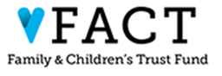
40th Anniversary Planning Committee
May 18th, 2026 11:00 A.M. – 12:00 P.M.
Virtual, Join the meeting now
Meeting ID: 252 663 408 091 754
Passcode: Ut77dv2q
+1 434-230-0065,,63079167#
Phone conference ID: 630 791 67

Agenda

11:00 Call to Order
Season Roberts

11:05 Review of 2026 Celebration & Awards Event
Amanda Abate Murphy

11:15 Review of Nomination Application & Timeline
Amanda Abate Murpy & Nicole Poulin

11:25 Determination of profile of the guest list
Season Robers & Nicole Poulin

11:55 Vote on final recommendations for Board consideration
Season Roberts

12:00 Adjournment
Season Roberts

